FREQUENTLY ASKED QUESTIONS:-
1) What is difference between SQL and SQL*PLUS?
SQL*PLUS is a command line tool where as SQL and PL/SQL language interface and reporting tool. Its a command line tool that allows user to type SQL commands to be executed directly against an Oracle database. SQL is a language used to query the relational database(DML,DCL,DDL). SQL*PLUS commands are used to format query result, Set options, Edit SQL commands and PL/SQL.
2) What are the data types allowed in a table ?
CHAR,VARCHAR2,NUMBER,DATE,RAW,LONG and LONG RAW.
3) Explain the differences between char and varchar2 data types.
When a column is of type char, the memory used will not be dependent on the value. It entirely depends on the bytes defined.
Example:
Name CHAR(10)
Each value will occupy 10 bytes of memory space even though the value may be of a smaller size.
When a column is of type varchar2, the memory used entirely depends on the value of the column
Example:
Name VARCHAR2(10)
Each value will occupy “x” bytes of memory space depending on the value.
To summarize, char data type is usually used when the value of fixed size is ascertained; for example Student id.
On the other hand, varchar2 should be used for variable length of data; for example Name.
4) How many types of Sql Statements are there in Oracle
There are basically 6 types of sql statments.They are
a) Data Definition Language(DDL) :: The DDL statements define and maintain objects and drop objects.
b) Data Manipulation Language(DML) :: The DML statements manipulate database data.
c) Transaction Control Statements :: Manage change by DML
d) Session Control :: Used to control the properties of current session enabling and disabling roles and changing .e.g. :: Alter Statements, Set Role
e) System Control Statements :: Change Properties of Oracle Instance .e.g.:: Alter System
f) Embedded Sql :: Incorporate DDL, DML and T.C.S in Programming Language.e.g:: Using the Sql Statements in languages such as 'C', Open, Fetch, execute and close
5) What are Codd Rules
Codd Rules describe the ideal nature of a RDBMS. No RDBMS satisfies all the 12 codd rules and Oracle Satisfies 11 of the 12 rules and is the only Rdbms to satisfy the maximum number of rules.
6) How many columns can table have?
The number of columns in a table can range from 1 to 1000.
7) Can you use select in FROM clause of SQL select ?
Yes.
8) Can you store pictures in database? How?
Yes , in long Raw datatype.
9) What are the types of SQL Statement ?
Data Definition Language :
CREATE,ALTER,DROP,TRUNCATE,REVOKE,NO AUDIT & COMMIT.
Data Manipulation Language:
INSERT,UPDATE,DELETE,LOCK
TABLE,EXPLAIN PLAN & SELECT.Transactional Control:
COMMIT & ROLLBACKSession Control: ALTERSESSION & SET
ROLESystem Control :
ALTER SYSTEM.
10) Explain BLOB, CLOB, NCLOB and BFILE. ?
These are the built in large object data types.
• BLOB, CLOB, NCLOB are stored internally where as BFILE is stored externally
• The BLOB data type stores binary large objects.
• The CBLOB data type stores character large objects.
• The NCBLOB data type stores character large objects in multibyte national character set.
• The BFILE data type enables access to binary file LOBs that are stored in file systems outside the Oracle database.
All these data types have a capacity of 4GB
11) Explain ROWID in oracle. ?
A ROWID in oracle is a pseudo column that is not within the database. It is used to uniquely identify a row with a table.
The rowid values are used to locate necessary information to locate a row.
Example:
Below query selects address of all rows that contain data for emp in department 20
Sql> SELECT ROWID,ename from emp
where deptno=20;
12) What is large object in oracle? Explain its purposes.
Large objects (LOB’s) are exclusively used to hold large amounts of data. It can hold data in tetra bytes. Different types of LOBs include internal, external, persistent and temporary. Binary LOB’s are typically used to store graphics, video, or audio data.
Purpose:
• Enables you to access and manipulate the data efficiently in your application
• Is optimized for large amounts of data
• Provides a uniform way of accessing data stored within the database or outside the database
13) Explain DCL command. ?
DCL: Data Control Language
DCL are used to configure and control database objects.
Following are the DCL commands:
GRANT
REVOKE

14) What is TCL command?
TCL - Transaction Control: statements used to manage the changes made by DML statements. It allows statements to be grouped together into logical transactions.
• COMMIT - save work done
• SAVEPOINT - identify a point in a transaction to which you can later roll back
• ROLLBACK - restore database to original since the last COMMIT
• SET TRANSACTION - Change transaction options like isolation level and what rollback segment to use
15) Differences between CHAR and NCHAR in Oracle.
Nchar is used to store fixed length Unicode data. It is often used to store data in different languages. CHAR on the other hand is store fixed length character data.
When data is stored using CHAR, it takes n bytes while NCHAR takes 2n bytes.
CHAR accepts up to 8000 characters while NCHAR accepts 4000 characters.
16) Differences between CHAR and VARCHAR2 in Oracle.
CHAR is used to store fixed length character strings where as Varchar2 can store variable length character strings. However, for performance sake Char is quit faster than Varchar2.
If we have char name[10] and store “abcde”, then 5 bytes will be filled with null values, whereas in case of varchar2 name[10] 5 bytes will be used and other 5 bytes will be freed.
17) Write the command to view the structure of the table.?
Write the command to view the structure of the table.
The desc table_name command is used to view the structure of the table.
18) Explain how to view all columns in an Existing Table.
Use the command DESC and the table name to view the information about the columns.
Eg:
SQL> desc emp;
Name Null? Type
------------ ------------ ----------
EMPNO NOT NULL NUMBER(4)
ENAME VARCHAR2(10)
JOB VARCHAR2(9)
MGR NUMBER(4)
HIREDATE DATE
SAL NUMBER(7,2)
COMM NUMBER(7,2)
DEPTNO NUMBER(2)
If you want to view the data stored in all the columns then use
Select * from table-name
Eg:
select * from emp;
19) Define CLOB and NCLOB datatypes.?
CLOB and NCLOB can both be used to store 4 GB of data in the database.
CLOB (Character Large Object) is used specifically to store character set data whole (single-byte character
set data).
NCLOB (National Large Object) is specifically used to store Unicode national character set data(multiple character sets.)
20) What is the BFILE datatypes?
Oracle provides Bfile datatypes to store unstructured binary data. The actual data is stored outside the database in the operating system files. A bfile column stores file locator that points to an external file containing data. Bfiles are read-only, one can’t modify them.
21) What is a database?
• Database offer a single point of mechanism for storing and retrieving information with the help of tables.
• Table is made up of columns and rows where each column stores specific attribute and each row displays a value for the corresponding attribute.
• It is a structure that stores information about the attributes of the entities and relationships among them.
• It also stores data types for attributes and indexes.
• Well known DBMS include Oracle, ibm db2, Microsoft sql server, Microsoft access, mysql and sqlLite.
21) Is it possible to modify a Data type of a column when column contains data ?
a] Yes
b] No
Ans B
22) Which of the following is not correct about the "TABLE" data type ?
a] Can contain any no of columns
b] Simulates a One-dimensional array of unlimited size
c] Column datatype of any Scalar type
d] None of the above
Ans : A
23) When we give SELECT * FROM EMP; How does oracle respond:
When we give select * from emp it will shows the records of table emp if the table contain records. If it hasn't any records then it will shows no rows selected.
24) What is the difference between "select * from table name" and "select column_name from table name" The above quiries are simple select quiries without having any "where" clause. Secondly which query will be performed faster and why??

The First Query will display all the columns
the second query will display on the Column_Name column.
the second query will be quicker than the first on.

25) How to find out the database name from SQL*PLUS command prompt?
Sql> select name from v$database will give u the database name from which u r currently Connected

26) What is the parameter substitution symbol used with INSERT INTO command?
& & is substitution variable.
eg. insert into table_name values (&column1, &column2);
The statement prompts for values of column1 and column2.
27) What is the use of DESC in SQL?
DESC has two purposes. It is used to describe a schema as well as to retrieve rows from table in descending order.
Explanation :
The query SELECT * FROM EMP ORDER BY ENAME DESC will display the output sorted on ENAME in descending order.
28) What is output of following query Select 2 from employee;
It depends upon number of rows in table. This query will print 2 as many times as rows in table.
29) What is spool command?
Spool command creates a print file of the report.
Spool command is used to sql file on the disk.
SQL>Spool drive name:path
30) How many LONG columns are allowed in a table? Is it possible to use LONG columns in WHERE clause or ORDER BY?
Only one LONG column is allowed. It is not possible to useLONG column in WHERE or ORDER BY clause.
31) What is the order of SQL statement execution?
here clause, Group By clause, Having clause, Order By clause & Select.
Q: select * from emp
where 1=1;
what is the output?
It will return all the records present in the table emp as
the condition 1=1 is true.

32) Advantages and disadvantages of attributes.
1. if more than one attribute has sane name then it will create the problem.
2. Attribute is the common media through which we can get the information about a entity.
33) Whats the back end processes when we type "Select * from Table"?
First it will look into the System Global Area (SGA) weatherthe query is been exectued earlier.
If it exist, it would retrive the same output present in memory.
If not the query we typed is complied and the resulting parse tree and excution plan is been stored in SGA. Then query gets executed and output is given to the application.
34) Explain about data retrieval?
Data retrieval syntax is often used in combination with data projection. This mechanism is used when there is a need forcalculated result. This is used when there is a special need for calculated data and not the verbatim data, which is different from the way it was stored in the database.
35) Which command displays the SQL command in the SQL buffer, and then executes it?
RUN.
36) The INSERT INTO Statements:
INSERT INTO table_name VALUES (value1, value2,....)
INSERT INTO table_name (column1, column2,...) VALUES (value1, value2,....)
37) What are the tables and structures in database?
A table contains rows and columns and Structure shows the type of column, size, constraints of that table
38) Which command executes the contents of a specified file?
START or @.
39) What is database?
A database is a collection of data that is organized so that its contents can easily be accessed, managed and updated.
another definition is:
A collection of information organized in such a way that acomputer program can quickly select desired pieces of data. You can think of a database as an electronic filing system.

40) Explain the where clause?
Where clause has a comparison predicate which restricts the number of rows as per the user generated query. This clause should be applied before the GROUP BY clause. This clause functions with the help of comparison predicate, when a comparison predicate does not evaluate a result to be true, all rows from the end result are deleted.
41) How to retrieve the image from thedatabase?
using BLOB object. we can store the images n access them.
42) What does preemptive in preemptive
Preemptive refers to the fact that each task is alloted fixed time slots and at the end of that time slot the next task is started.
43) What are the data types allowed in a table?
CHAR, VARCHAR2, NUMBER, DATE, RAW, LONG and LONG RAW.
44) what are the SELECT statements?
SELECT column_name(s) FROM table_name
SELECT DISTINCT column_name(s) FROM table_name
SELECT column FROM table WHERE column operator value
SELECT column FROM table WHERE column LIKE pattern
SELECT column,SUM(column) FROM table GROUP BY column
SELECT column,SUM(column) FROM table GROUP BY column HAVING SUM(column) condition value
Note that single quotes around text values and numeric values should not be enclosed in quotes. Double quotes may be acceptable in some databases.
44) Which command displays the SQL command in the SQL buffer, and then executes it?
RUN.
45) How do you generate file output from SQL?
By use of the SPOOL command

46)What is sql?
Structured Query Language SQL, which stands for Structured Query Language, is a special-purpose language used to define, access, and manipulate data. SQL is nonprocedural, meaning that itdescribes the necessary components (i.e. tables) and desiredresults without dictating exactly how results should be computed.
47) What is the difference between two null values in a column?
No two values are same and if we compare two null values each other the value is garbage. we cannot determine the value
48) How many codds rule should oracle satisfies
Oracle can support codd's 11.5 rules.
view updated rules fully not supported in oracle.
49) What is difference between SQL and SQL*PLUS?
SQL*PLUS is a command line tool where as SQL and PL/SQL language interface and reporting tool. Its a command line tool that allows user to type SQL commands to be executed directly against an Oracle database. SQL is a language used to query the relational database(DML,DCL,DDL). SQL*PLUS commands are used to format query result, Set options, Edit SQL commands and PL/SQL.
50) What is difference between blob and clob in oracle?
The main difference between BLOB and CLOB in Oracle are :
* BLOB stores values as LOB (Large Object) in bitstreams
* CLOB Stores values as LOB (Large Object) in character streams.
1) How you will avoid duplicating records in a query?
By using DISTINCT
2) What are various Oracle Operator?
Different operators:
Unary operators:- Operates on one operand.
Binary:- Operates on two operands.
Arithmetic operators:- Used to perform basic arithmetic operations like addition, subtraction etc. they are listed below:
• + - - Denotes positive or negative expression. They are unary operators.
• */- Denotes multiplication or division. They are binary operators.
• ||- Concatenates strings
• =, !=. <, >, <=, >= are all comparison operators.
• OR, AND, NOT are all logical operators
Example:
sql>SELECT * FROM emp
WHERE job = 'CLERK'
AND deptno = 10;
3) What is IN operator?
IN operator in a query allows you to have multiple values in a WHERE clause.
Example: to return records of employees staying in Pune and Mumbai.
sql> select *from dept
where loc in('NEW YORK','CHICAGO');
4) What is Like operator?
LIKE in oracle enables the user to search for a string of the matching type. “%” is used as a wild card in the query.
Example:
The query below will display results of employee names starting with A
Sql> SELECT ename FROM emp WHERE ename LIKE 'A%';
5) Define Is Null operator.
IS NULL operator is usually used to check if a columns value is NULL or not.
Example:
Sql> select *from emp where comm is not null;
6) What are the comparison operators in oracle. List them with description
Comparison operators in oracle are used to compare data. Such operators are used in WHERE clause.
List of such operators:
1)= -> EQUAL TO
2)<> != -> Both means NOT EQUAL TO
3)< LESS THAN
4)> GREATER THAN
5)<= >= -> LESS THAN OR EQUAL TO, GREATER THAN OR EQUAL TO
6)ANY- compares one value with any value
Example:
sql>Select * from employee
Where sal >=2000;
7) What is the Result of the following 'VIK'||NULL||'RAM' ?
a] Error
b] VIK RAM
c] VIKRAM
d] NULL
Ans : C
8) What are the wildcards used for pattern matching.
The "LIKE" operator performs the pattern matching in SQL.
for single character substitution and % for multi-charactersubstitution.
9) SQL>select * from EMP
where ename like 'A%';
State true or false.
!=,
<>,
^=
all denote the same operation.
Answer: True.

10) What operator tests column for absence of data?
IS NULL operator.

11) Operators used in SELECT statements.
= Equal
<> or != Not equal
> Greater than
< Less than
>= Greater than or equal
<= Less than or equal
BETWEEN Between an inclusive range
LIKE Search for a pattern

12) Display the records between two range?
Sql>select * from emp where sal between 1000 and 3000

13) Which command displays the SQL command in the SQL buffer, and then executes it?
RUN.

1) What is difference between SUBSTR and INSTR?
SUBSTR returns a specified portion of a string eg SUBSTR('BCDEF',4) output BCDE INSTR provides character position in which a pattern is found in a string. eg INSTR('ABC-DC-F','-',2) output 7 (2nd occurence of '-')

2) Display the number value in Words?
Sql> select sal, (to_char(to_date(sal,'j'), 'jsp'))
from emp;

3) When do you use WHERE clause and when do you use HAVING clause?
HAVING clause is used when you want to specify a condition for a group function and it is written after GROUP BY clause. The WHERE clause is used when you want to specify a condition for columns, single row functions except group functions and it is written before GROUP BY clause if it is used.

4) How do you find the numbert of rows in a Table ?
A bad answer is count them (SELECT COUNT(*) FROM table_name)
A good answer is :-
'By generating SQL to ANALYZE TABLE table_name COUNT STATISTICS by querying
Oracle System Catalogues (e.g. USER_TABLES or ALL_TABLES).
The best answer is to refer to the utility which Oracle released which makes it unnecessary to do ANALYZE TABLE for each Table individually.

5) How many LONG columns are allowed in a table ? Is it possible to use LONG columns in WHERE clause or ORDER BY ?
Only one LONG columns is allowed. It is not possible to use LONG column in WHERE or ORDER BY clause.

6) What is NVL() function?
Oracle deals with Null values using NVL function. The function replaces the NULL value in the given column with the value provide to it. The function accepts two parameters, the first one is the column name and the second one is the value with which NULL has to be replaced.
Example
Sql> select nvl(comm,0) from emp;

7) Describe the use of following oracle numeric functions with an example.?
NVL
ABS,CEIL,FLOOR, MOD
SQRT
EXP,LN AND LOG
ROUND AND TRUNC
AVG, COUNT, MAX, MIN AND SUM
STDDEV AND VARIANCE
DISTINCT AND LIST function

8) What are conversion functions?
CHARTOROWID
Converts a string to a ROWID.
CONVERT
Converts a string from one character set to another.
HEXTORAW
Converts from hexadecimal to raw format.
RAWTOHEX
Converts from raw value to hexadecimal.
ROWIDTOCHAR
Converts a binary ROWID value to a character string.
TO_CHAR
Converts a number or date to a string.
TO_DATE
Converts a string to a date.
TO_NUMBER
Converts a string to a number.

9) What is nested function?
When one function is called inside the other, it is called a nested function.

10) What are SQL functions in oracle?
There are two types of functions –
Single row that operates row by row. Group function operates on multiple rows.
Functions that fall under single functions are Date, Numeric, Character, Conversion and miscellaneous function
Functions that fall under group functions are avg, max, min, count, and sum.

11) Explain the use of Translate Function in Oracle?
The translate function performs a character wise replacement of a string. The syntax is as follows:
translate( input_string , string1 , string2 )
string1: this is the string which will be looked for in the input string
string2: this is the string that will replace the string1 characters in the input string.
Example:
Sql>select translate('HELLO123','L21','Ixy') from dual;
Output:
TRANSLAT
--------
HEIIOyx3

12) What is translate and decode in oracle?
Translate: translate function replaces a sequence of characters in a string with another set of characters. The replacement is done single character at a time.
Syntax:
translate( string1, string_to_replace, replacement_string )
Example:
translate ('1tech23', '123', '456);
Decode: The DECODE function compares one expression to one or more other expressions and, when the base expression is equal to a search expression, it returns the corresponding result expression; or, when no match is found, returns the default expression when it is specified, or NA when it is not.
Syntax:
DECODE (expr , search, result [, search , result]... [, default])
Example:
sql>SELECT employee_name, decode(employee_id, 10000, ‘tom’, 10001, ‘peter’, 10002, ‘jack’ 'Gateway') result
FROM employee;

13) What are Group Functions in Oracle?
COUNT():
This function returns the number of rows in the group. A column name or ‘*’ may be passed as a parameter.
MIN(column_name):
This ffunction returns the minimum value of the expression evaluated on each row of the group.
MAX(column_name):
It returns the maximum value of the expression evaluated on each row of the group.
AVG(column_name):
It returns the average value of the expression evaluated on each row of the group.

14) Describe the use of following oracle string functions with an example.?
Concatenation(||)
RPAD and LPAD
Ltrim, Rtrim and Trim
LOWER, UPPER, and INITCAP
LENGTH
SUBSTR
INSTR
ASCII AND CHR
SOUNDEX

15) what is COALESCE function?
- This function is used to return the value which is set not to be null in the list.
- Incase all values in the list are null the coalesce function will return NULL.
- Its representation:
Coalesce(value1, value2, value3,…)
16) Differentiate between: a.) TRANSLATE and REPLACE.
Translate is used to substitute character by character.
- Replace is used to substitute a single character with a word.

17) Explain how to sort the rows that are retrieved by a query.?
Rows that are returned by a query can be sorted using the ORDER BY clause. By default the rows are sorted in an ascending order.
Example:
sql>Select * from emp ORDER BY sal DESC;

18) Explain how to sort the rows that are retrieved by a query.?
Rows that are returned by a query can be sorted using the ORDER BY clause. By default the rows are sorted in an ascending order.
Example:
sql>Select * from emp ORDER BY sal DESC;

19) Describe the use of following oracle date functions with an example.
Sysdate
Current_date
SYSTIME STAMP
ROUND and TRUNC in date calculation
TO_DATE and TO_CHAR formatting
1. Sysdate
Sydate in Oracle /PLSQL is used to return the current date and time of the system in which the database is configured.
Example:-
Returns the System date and employee from the table
Select SYSDATE, id from employee Where emp_id >100;
2. Current_date
Current_date in Oracle /PLSQL is used to return the current date of the time zone of the existing or running SQL session.
Example:
Select current_date from employee Will return: 16-JAN-2010 10:14:33
3. SYSTIMESTAMP
SYSTIMESTAMP in Oracle /PLSQL is used to return the current system (on which the database is configured) date and time which includes fractions of seconds and time zone.
Example:
Select SYSTIMESTAMP from employee Will return: 16-JAN-10 12.38.55.538741 PM -08:00
4. ROUND and TRUNC in date calculation
ROUND in Oracle /PLSQL is used to return the next rounded value of a number. The number of decimal places to be rounded is determined by a parameter.
Example:
ROUND(120.411) will return 120
ROUND(120.411, 1) will return 120.4
Select ROUND(salary_amt,2) from employee
TRUNC in Oracle /PLSQL is used to scrap or truncate the number of digits specifed. The number of digits to be truncated is determined by a parameter.
Example:
TRUNC(120.411, 1) will return 120.41
Select TRUNC(salary_amt,2) from employee
5. TO_DATE and TO_CHAR formatting
TO_DATE function in Oracle /PLSQL is used to convert a given string in DATE format.
Example:
to_date('2010/07/09', 'yyyy/mm/dd') would return a date value of Jan 10, 2010.
TO_CHAR function in Oracle /PLSQL is used to convert a given number (DATE or number) to string.
Example:
to_char(sysdate, 'FMMonth DD, YYYY'); would return ‘Jan 10, 2010'
Here, FM parameter suppresses the blank spaces and zeros.

20) 13) SQL single-row character munipulation functions?
SQL single-row character munipulation functions
CONCAT(string1, string2)
INITCAP(string)
LENGTH(string)
LPAD(string, #,padding_char)
RPAD(string, #,padding_char)
LTRIM(string,searchString)
RTRIM(string,searchString)
REPLACE(string,searchString,replacement)
SUBSTR(string,start,length)
UPPER(string)
LOWER(string)

21). TRANSLATE('333SQD234','0123456789ABCDPQRST','0123456789') will return

a] 333234 b] 333333
c] 234333 d] None of the above

Ans : A

22) EMPNO ENAME SAL
A822 RAMASWAMY 3500
A812 NARAYAN 5000
A973 UMESH
A500 BALAJI 5750
Using the above data Select count(sal) from Emp will retrieve
a] 1 b] 0 c] 3 d] None of the above
Ans : C

23) REPLACE('JACK AND JUE','J','BL') will return
a] JACK AND BLUE b] BLACK AND JACK
c] BLACK AND BLUE d] None of the above
Ans : C

24) SUBSTR(SQUARE ANS ALWAYS WORK HARD,14,6) will return
a] ALWAYS b} S ALWA c] ALWAYS
Ans : C

25)What is the default format of date in Oracle? How can I change my default date format?
The default format for date in oracle is DD-MON-YY.
We can change it by using this SQL commnd
ALTER SESSION set nls_date_format='desired format';
Desired format is like Day-Mon-yyyy 24hh:mi:ss

26) What is the output of the following query
SELECT TRUNC(1234.5678,-2) FROM DUAL;
Sql>
Answers: 1200.
'trunc' is not a recognized built-in function name.so use select round(1234.5678,-2) from 'tablename'. this funtion work well.
27) What does the following query do?
SELECT SAL + NVL(COMM,0) FROM EMP;
This displays the total salary of all employees. The null values in the commission column will be replaced by 0 and added to salary.
whrerever the commission is null, it is replaced by 0 & added to the salary.

28)Which date function is used to find the difference between two dates?
we have to use months_between date function which returns float value.
Sql>select months_between('07-jun-2007','02-jun-2006') from dual;
to get result in integer use round function with it.
sql>select round(months_between('07-jun-2007','02-jun-2006')) from dual;

29)What will be the output of the following query?
SELECT REPLACE(TRANSLATE(LTRIM(RTRIM('!! ATHEN !!','!'), '!'), 'AN', '**'),'*','TROUBLE') FROM DUAL;
Answers:
TROUBLETHETROUBLE.
i will explain:
1st step : rtrim('!!athen!!','!') its out put come like this "!!athen"
2nd step: ltrim('!!athen','!') its out put come "athen"
3rd step :trancelate('athen','an','**') its output come like this "*the*"
4th step :replace('*the*','*','trouble')
finally its output being look like this "trouble the trouble"

29)What is difference between DBMS and RDBMS?
RDBMS have Normalization. Normalization means to refining the redundant and maintain the stablization.
the DBMS hasn't normalization concept.
1.RDBMS=DBMS+Refrential Integrity
2. An RDBMS ia one that follows 12 rules of CODD.
_______________________________________
RDBMS we can make it as a server, it connect more systems but DBMS only woke in host system,we can't make dbms as global..

30)What are two methods of retrieving SQL?
1-select
2-using cursour

31) Explain about SQL related to RDBMS?
SQL is known as structured query language. It is especially designed to retrieve and store information of data in relational database management systems. It creates, modifies and makes the data base object user access the control system. It is primarily specialized software for RDBMS.

32)Which function is used to find the largest integer less than or equal to a specific value?
Syntax
FLOOR (n)
Purpose
Returns largest integer equal to or less than n.
Example
sql>SELECT FLOOR(15.7) "Floor" FROM DUAL;
Returns the following result.
Floor
---------
15

33)How to get short name & long name of the month or month of given date
select to_char(inputdate,'mon') as shortname,
to_char(inputdate,'month') as longname from
(select
to_date(&sa_dt,'dd-mon-yy') inputdate
from dual);

34) I have table t1
a phy 30
b che 10
c math 25
a math 40
b che 30
c phy 50
a che 20
b math 70
c phy 45
Write a qurire find out the max marksof each subject?
create table tblMarks(id int , sub varchar(100), marks int)
insert into tblMarks values(1, 'phy', 20)
insert into tblMarks values(2, 'phy', 50)
insert into tblMarks values(3, 'math', 90)
insert into tblMarks values(4, 'math', 30)
insert into tblMarks values(5, 'che', 80)
insert into tblMarks values(6, 'che', 10)
insert into tblMarks values(7, 'phy', 76)
select sub, max(marks) from tblMarks group by sub

35)What does the following query do
SELECT SAL + NVL(COMM,0) FROM EMP;
It gives the added value of sal and comm for each employee in the emp table.
NVL(null value) replaces null with 0.

36)What is the output of the following query SELECT TRUNC(1234.5678,-2) FROM DUAL;?
1200.

Q. How do we select the employees detail from the table who were joined in the last 5yrs?
Sql> select * from emp
where to_char(hiredate,'yyyy')=to_char(sysdate,'yyyy')-5;

37) Display department which has maximum no'of employees?
select deptno, count(deptno) No_of_employee
from emp group by deptno

37) You want to group the following set of select returns, what can you group on? Max(sum_of_cost), min(sum_of_cost), count(item_no), item_no?
The only column that can be grouped on is the "item_no" column, the rest have aggregate functions associated with them.

38)Display the number value in Words?
SQL> select sal, (to_char(to_date(sal,'j'), 'jsp'))
from emp;
the output like,
SAL (TO_CHAR(TO_DATE(SAL,'J'),'JSP'))
--------- -----------------------------------------------------
800 eight hundred
1600 one thousand six hundred

39)There is a string 120000 12 0 .125 , how you will find the position of the decimal place?
Sql>select INSTR('120000 12 0 .125','.',1) from dual

Que: What is difference between date and timestamp in oracle>
Answer:


40) How to convert numbers to character in oracle?
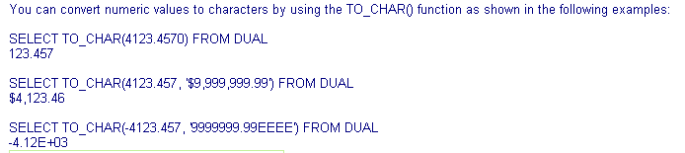

41)how convert characters to numbers in oracle?
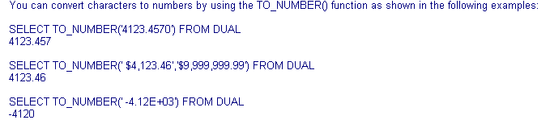

43) How to convert dates to characters in oracle?
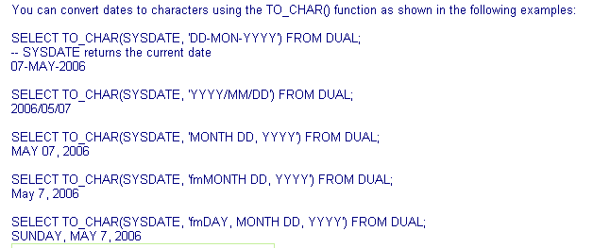

44)
Answer:
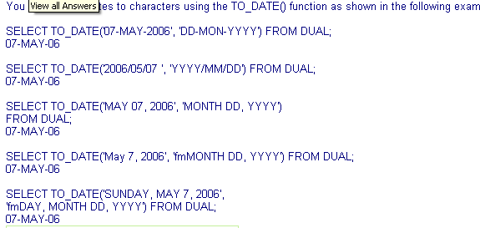

45) How to convert times to characters in oracle?
Answer : 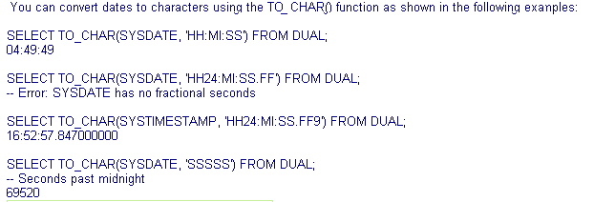

46) How to convert characters to times in oracle?
Answer:
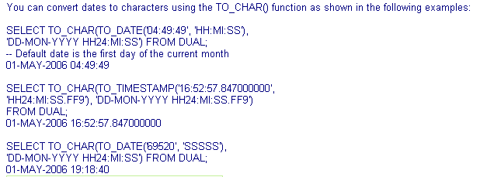

47) How to use null as conditions in oracle?
Answer:
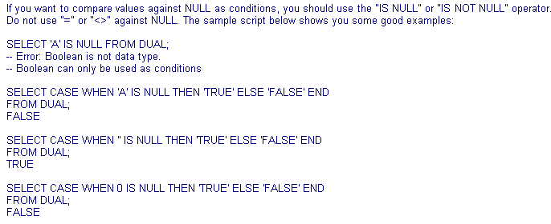
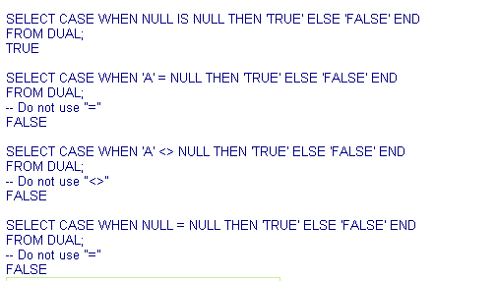

48) How to concatenate two text values in oracle?
Answer:
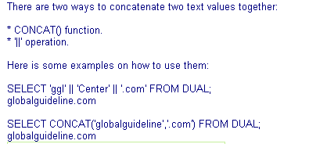

.49) How to increment dates by 1 in oracle?
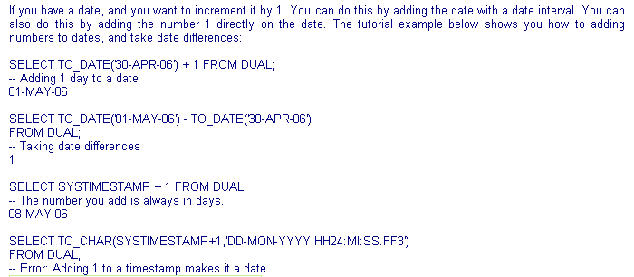

50) How to calculate date and time differences in oracle?
Answer:
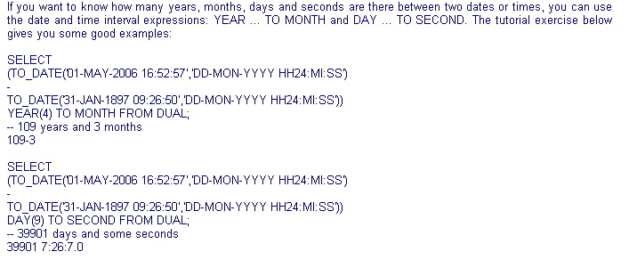
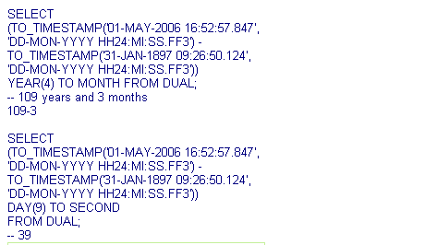

51) How to use in condition in oracle?
Answer:
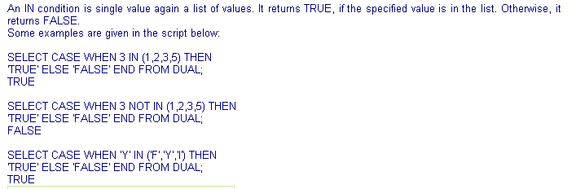

52) How to use like condition in oracle?
Answer:
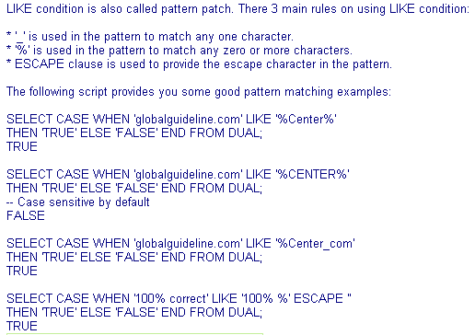

53) How to use regular expression in pattern match conditions in oracle?
Answer:
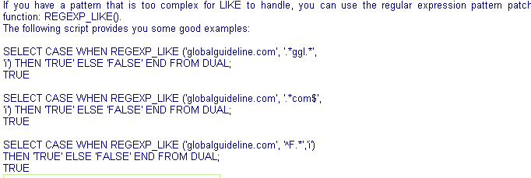
54) Can the query output be sorted by multiple columns in oracle?
Answer:-
Sql> select deptno,ename,sal from emp
order by deptno,sal;
54) How to sort output in descending order in oracle?
Answer:
Sql> select deptno,ename,sal from emp
order by deptno desc ,sal
55) How to use group functions in the select clause using oracle ?
Answer:
Sql> select count(deptno),min(deptno),max(deptno) from emp;

56) Can group functions be mixed with non group selection fields?
Answer:
Sql> select count(*),deptno from emp;
Error:
ORA-00937: not a single-group group function

57) How to apply filtering criteria at group level in oracle?
Answer:
Sql> select deptno,min(sal),max(sal) ,avg(sal) from emp
group by deptno
having avg(sal)<2000;

58) Can group functions be used in the order by clause in oracle?
Answer:
Sql> select deptno,sal,count(*) from emp
group by deptno,sal
having count(*)>1
order by count(*) desc;

